3GPP TSG RAN WG1 Meeting #83 R1-157436
Anaheim, USA, 15th - 22th November 2015
______________________________________________________________________Agenda item: 6.2.8.1.2
Source: LG Electronics
Title: Discussion on DMRS density and structure to handle high Doppler case
Document for: Discussion and Decision
- Introduction
In the RAN1#82bis meeting, the following agreement is made on the enhancement of DMRS to handle high Doppler case:

Agreements:
- The following observation is captured in TR: “DMRS needs to be enhanced for PC5-based V2V”
- Baseline: SC-FDM is used for V2V transmission in each physical channel
- Enhancement at least includes:
  - Increase DMRS density to reduce time interval between DMRS sequences
  - Enhance DMRS structure to increase frequency offset compensation range
- Study at least the following DMRS structure:
  - Reuse PUSCH DMRS
  - Other options are not precluded, i.e.,
    - PUSCH DMRS with Comb (similar as structure of SRS)
    - New DMRS patterns spread over time and frequency, that may be frequency multiplexed with DFT-precoded data at least in some symbols
    - Increased subcarrier spacing
  - All options should solve any complexity and standardization impact including analysis of frequency synchronization accuracy

In this contribution, we discuss RS enhancements to handle high Doppler case.
- Discussion on DMRS structure to handle high Doppler frequency
In RAN1#82 meeting, carrier frequency and vehicle speed are agreed for the simulation assumptions. The highest carrier frequency is 6GHz, and the maximum vehicle speed is 140km/h. The higher carrier frequency and faster speed than previous study would make channel suffer from ICI and phase drift.
Assuming that residual frequency offset after synchronization is 0.1ppm, the maximum frequency offset of channel between two vehicles is 1.2 KHz at 6GHz carrier frequency. The phase drift by frequency offset has linear characteristic on time, and the value exceeds after it passed 6 SC-FDMA symbols with normal CP. If current two SC-FDMA symbols DMRS with 7 symbol-interval is used to compensate frequency offset, ambiguity on the measurement of linear phase drift can take place due to the value more than . It needs to design DMRS having shorter symbol-interval than current one.
Considering the maximum 140km/h of vehicle speed, relative speed is 280km/h. Doppler effects by high vehicle speed also causes severe phase drift, but it has not linear characteristic on time. If channel has just one path, phase by Doppler effects would linearly vary. Maybe, LOS environment with one dominant path can assume approximately linear phase drift, which can be mathematically expressed with one exponential function. However, summing up different exponential functions in multi-path in NLOS environment, phase drift has fluctuation on time. To compensate it, assuming phase drift is roughly linear function of time, the phase offset obtained by DMRS can be applied for the data channel only around the DMRS in the data channel estimation. To facilitate the approach, the density of DMRS needs to be higher so that DMRS always can be mapped near all the data symbols.
There is trade off relationship between RS density and data rate. Observing internal simulations, 4 symbol DMRS design seems to be proper. We can list candidate enhancements as follows:
- Method 1: 4 symbol DMRS positioned at #2, #4, #8, #10
- Method 2: 4 symbol comb-type DMRS positioned at #2, #5, #8, #11
- Method 3: Every symbol contains RS by subcarrier-wise FDM of RS and data whiling keeping the overhead equivalent to the current PSCCH/PSSCH
RS mapping for each method is depicted in Fig. 1. When designing RS mapping, we considered that the first and last symbols are punctured. In this figure, method 1 has 2 symbol DMRSs in each slot with 2 symbol interval between DMRS at the expense of 4 symbol interval between two center-positioned DMRSs. Unlike this, 4 DMRS symbols can be mapped on #2, #5, #8, #11 symbols with equally 3 symbol interval. However, 3 symbol spacing is not sufficient to handle the phase draft of high Doppler by relative speed 280km/h and high frequency offset on 6GHz. Since phase draft value varies rapidly, there can frequently be ambiguity on measurement of phase offset between 3 symbol spacing. This is why method 1 showed the better performance than other possibilities.
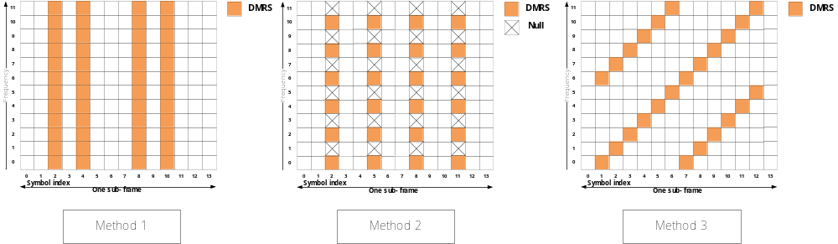
Fig. 1: RS mapping for each method
Method 1 has the limitation that fast phase change within one or two symbol times cannot be estimated between two center-positioned DMRSs. To address it, comb-type DMRS such as method 2 can be applied for the offset compensation. Using comb-type RS, time signal is repeated twice within an OFDM symbol. By comparing two repeated RS sequence components in an RS symbol, very fast phase offset can be estimated. Therefore, interval size between RSs is not relevant on the estimation ability about phase offset, and thus, DMRS can be mapped with equally spacing between RSs, as shown in figure 1. Phase offset obtained on DMRS is applied for the compensation of only two neighboring data symbols on both hands of the RS, so that compensation ability can be better than method 1’s.
Another alternative is method 3 proposed in [2], where RSs are FDMed with data signals in every OFDM symbol by mapping RS sequences in every 6 subcarriers. This structure allows channel estimation at every symbol, but as discussed in [1], this structure has issues in MPR and IBE as it does not follow the SC-FDM characteristics of UE transmissions in current LTE.
The process of estimate and compensation of phase offset is described in more detail in Appendix A.
- Simulations
- Data channel
We evaluated data channel of three models described in section 2. We simulated them in NLOS environment. In the simulation, 6.0GHz carrier frequency, {30km/h, 280km/h} relative speed, {190, 300, 800} bytes message sizes are assumed. For the transmission, multi-subframe transmission is assumed: {10RB, 2 subframes for 190byte}, {10RB, 3 subframes for 300byte}, {20RB, 4 subframes for 800byte}. Also, we assumed the puncturing of the first and last symbols in the simulation. We plot the cases of 1.2KHz frequency offsets in figures 2, 4, 6, and 2.4KHz frequency offsets in figures 3, 5, 7. In each figure, two relative speeds of 30km/h and 280km/h are used to check the variation of performance depending on speed. In the figures, legend represents vehicle speed, not relative speed. The detailed simulation assumptions are given in Appendix B.
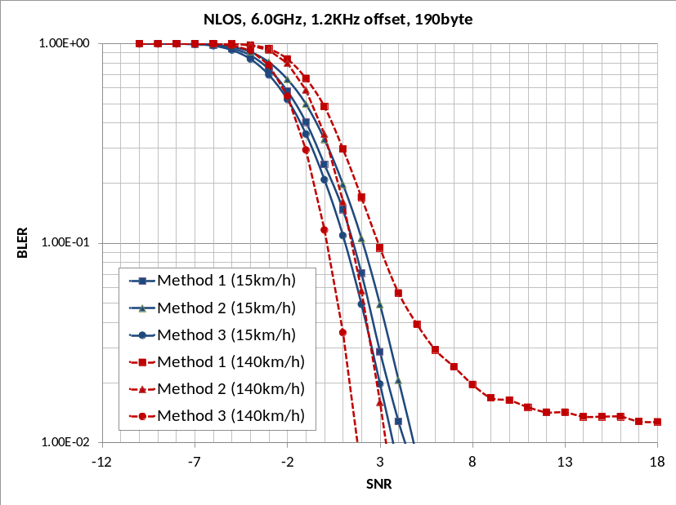
Fig. 2: Comparison the performance among methods 1, 2 and 3 assuming 1.2KHz frequency offset, {10RB, 2 subframes} and 190byte.
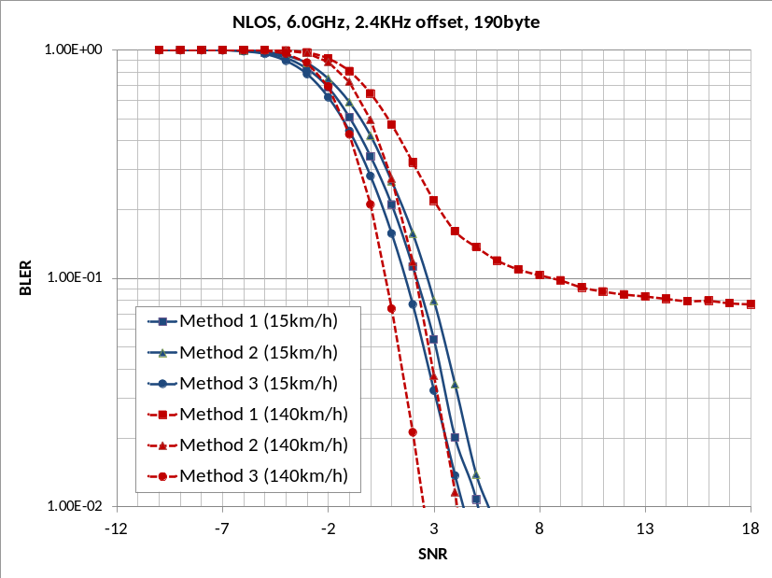
Fig. 3: Comparison the performance among methods 1, 2 and 3 assuming 2.4KHz frequency offset, {10RB, 2 subframes} and 190byte.
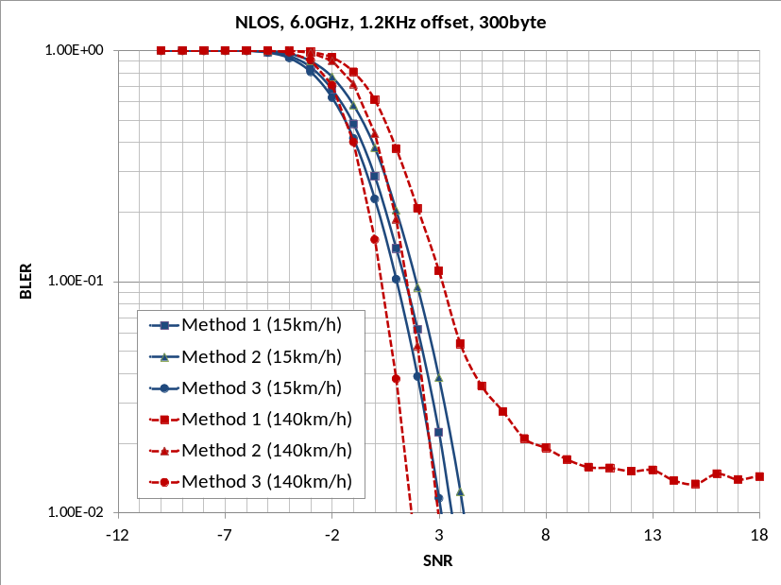
Fig. 4: Comparison the performance among methods 1, 2 and 3 assuming 1.2KHz frequency offset, {10RB, 3 subframes} and 300byte.
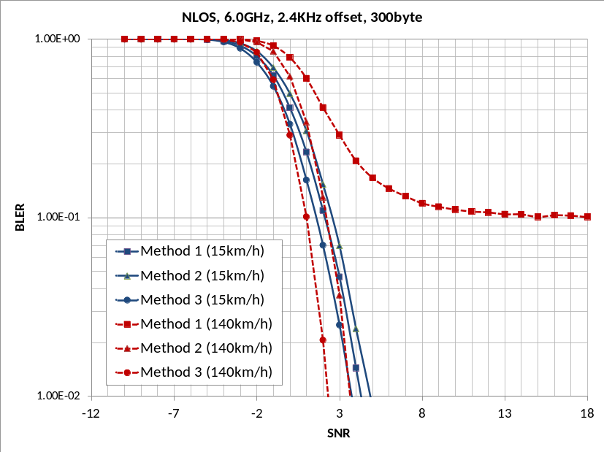
Fig. 5: Comparison the performance among methods 1, 2 and 3 assuming 2.4KHz frequency offset, {10RB, 3 subframes} and 300byte.
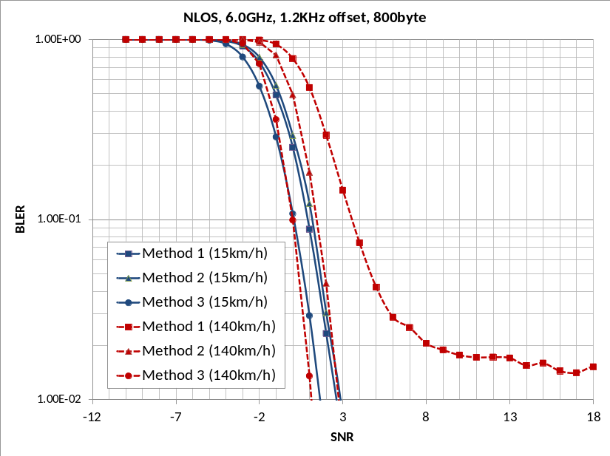
Fig. 6: Comparison the performance among methods 1, 2 and 3 assuming 1.2KHz frequency offset, {20RB, 4 subframes} and 800byte.
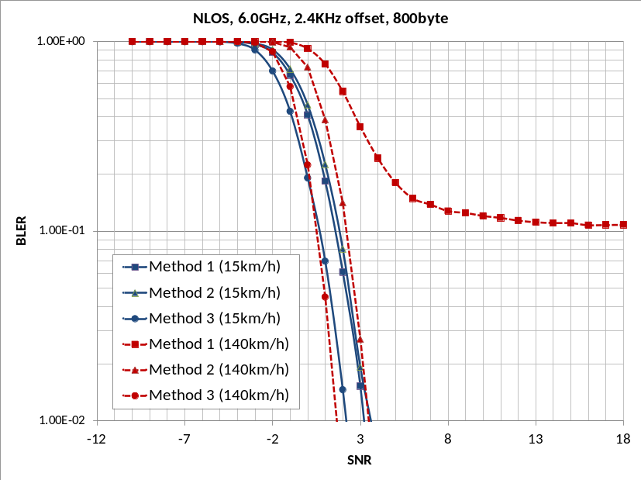
Fig. 7: Comparison the performance among methods 1, 2 and 3 assuming 2.4KHz frequency offset, {20RB, 4 subframes} and 800byte.
It can be observed in figures 2 ~ 7 that for relative speed 280km/h, method 2 has a better performance compared to method 1 whose performance even represents floor character. It is because that the compensation of phase offset is carried out by using neighboring DMRS for all the data symbols in method 2, while #6 and #12 data symbols can be compensated by two symbol spaced DMRS in method 1, so that it doesn’t work well by non-linearity character of phase rotation. Also, method 2 estimates the phase offset from comparing the phase variation on 0.5 symbol interval, while method 1 estimates the phase offset from comparing the phase variation on 2 symbol interval. Sometimes, rapid varying phase offset would be difficult to be estimated by method 1.
Also, we simulated enhanced method 1, which is expressed as method 1’. Method 1’ uses the same symbol mapping of method 2. The channel estimation algorithm of method 1’ is different from that of method 1. To be specific, for method 1’, the compensation for frequency error is carried out per subframe, not slot as described in detail in Appendix A. We plot the evaluation results for {10RB, 2 subframes for 190byte}, {10RB, 3 subframes for 300byte}, {20RB, 4 subframes for 800byte} in figures 8, 9, 10, respectively. For each simulation, both of 1.2kHz and 2.4kHz frequency offsets are assumed.
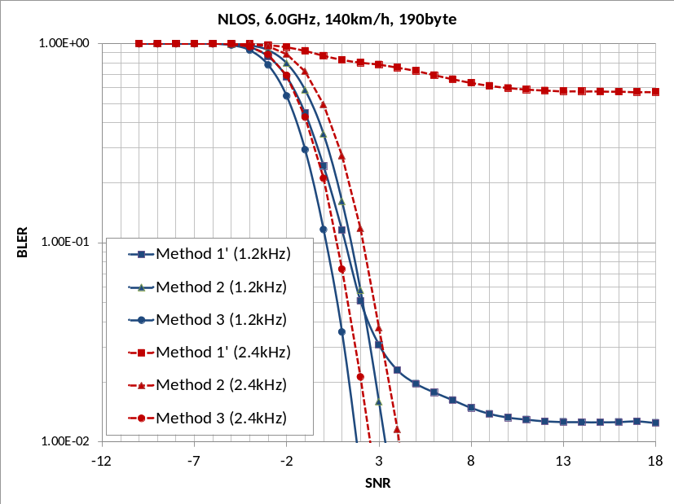
Fig. 8: Comparison the performance among methods 1’, 2 and 3 assuming 140km/h, {10RB, 2 subframes} and 190byte.
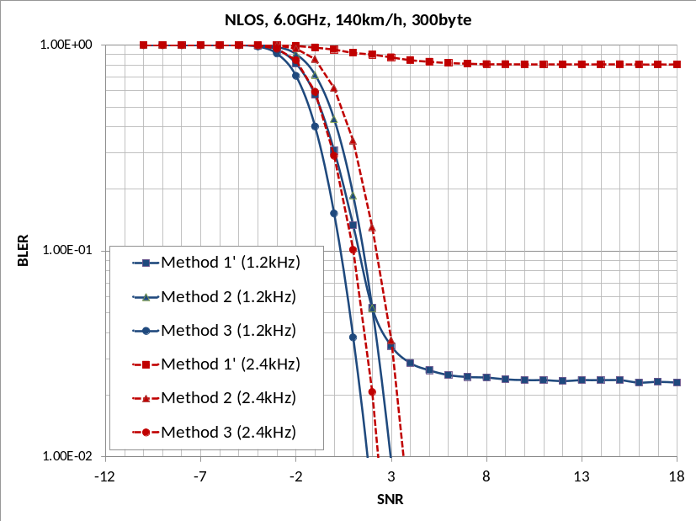
Fig. 9: Comparison the performance among methods 1’, 2 and 3 assuming 140km/h, {10RB, 3 subframes} and 300byte.
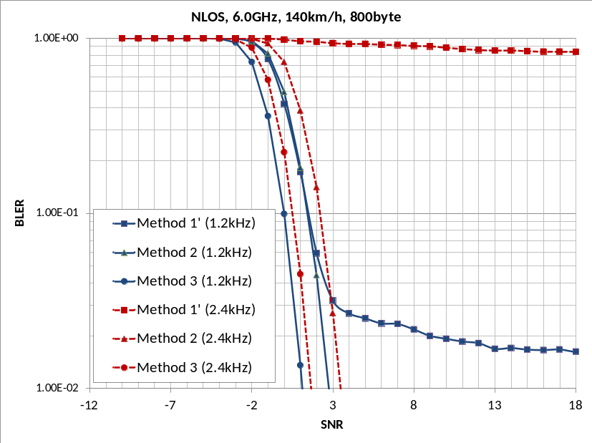
Fig. 10: Comparison the performance among methods 1’, 2 and 3 assuming 140km/h, {20RB, 4 subframes} and 800byte.
It can be observed in figures 2 ~ 10 that the performances of method 1’ is better than those of method 1 at 1.2kHz frequency offset, but method 1’ still suffer from error floor in high SINR range. Also, it is observed that method 1’ does not operate at 2.4kHz offset. The channel structure of method 1 and method 1’ has difficulty in compensating 2.4kHz frequency offset due to ambiguity for the phase offset, since phase rotation goes over as DMRS spacing is larger than 14symbols/4.8 = 2.92 symbols. Note that method 2 compensates frequency offset by comparing between 0.5 symbol spacing DMRS.
In addition, we can observe in figures 2 ~ 10 that for relative speed 280km/h, the performance of method 3 is better than that of method 2 with the gain of 1.2 dB ~ 1.7 dB at the 0.1 BLER depending on the different message size. This gain of method 3 mainly comes from even better channel estimation compared to method 2 by placing DM RS in every symbol.
However, the OFDM structure has higher PAPR which requires transmit power reduction. In [1], it shows CM comparison for OFDM, SC-FDM, and 2H in [2] and concludes that method 3 needs 2dB power reduction. Considering MPR of 2dB for method 3, we can calculate MCL in Table 1. It can be shown in table 1 that method 2 has larger MCL than method 3.
Table 1: Comparison between MCL of method 2 and method 3 for 1.2KHz frequency offset
 |  | Method 2 | Method 3
190byte | 15km/h | 123.37dB | 122.33dB
190byte | 140km/h | 124.01dB | 123.33dB
300byte | 15km/h | 123.55dB | 122.45dB
300byte | 140km/h | 123.95dB | 123.15dB
800byte | 15km/h | 121.30dB | 120.40dB
800byte | 140km/h | 121.05dB | 120.15dB

Method 3 has another drawback of being vulnerable to delay spread and timing error. Method 3 can be regarded as 6 comb type RS mapping. Then, the sequence of method 3 is repeated six times in each RS symbol with each being 1/6 OFDM duration, while the sequence of method 2 is repeated two times in time domain with each being 1/2 OFDM duration. Assuming using Zadoff-Chu sequence like D2D DMRS, the time duration would be more reduced by 12 CS. Then, while the time duration of method 2 is 66.67/2/12 = 2.778us, the time duration of method 3 is 66.67/6/12 = 0.926us. Therefore, method 3 is vulnerable to delay spread more than 1us [3].
Related to the weakness against the delay spread, we can consider timing delay in the reception of interference link, which effectively increases make delay spread from the receiver point of view. In current Rel.12 D2D specification [4], transmit timing is required within 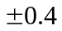or 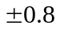us with respect to the received timing reference. Thus, the maximum error in transmitting timing of two UEs can be up to 0.8 or 1.6 us. Also, considering V2X target range around 300m, propagation delay can be up to 1us. In addition, signal for synchronization reference can arrive at different timing (e.g., due to the difference in the propagation time from the eNB) at different UEs. All these aspects can make reception timing difference of multiple UE signals at each receiver.
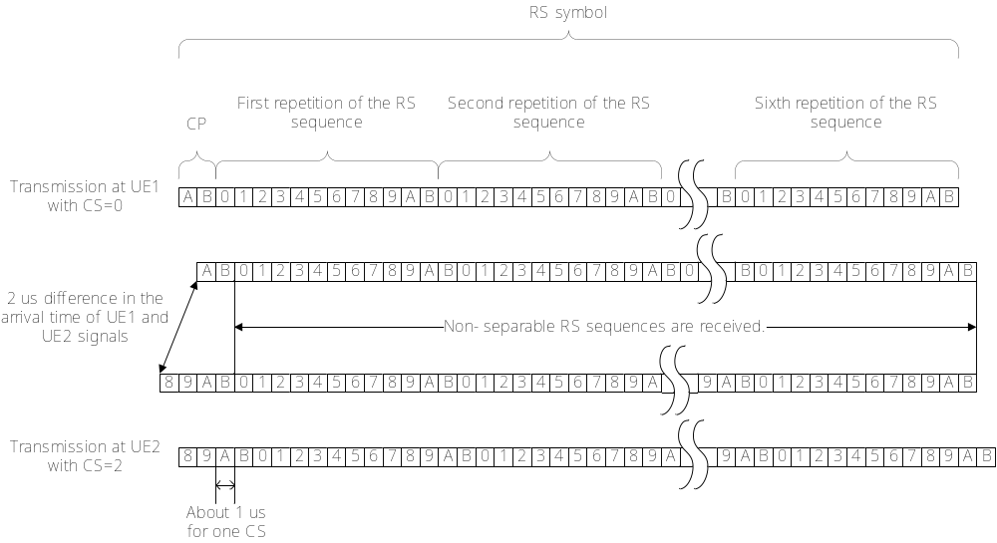
Fig. 11: Overlapped sequences between Tx UE and interference UE with 2us reception timing delay and CS interval 2 in method 3.
Assuming reception timing delay is 2us and time duration of method 3 is 1us, we can depict the problem by summing the delay spread and timing delay in figure 11. In this figure, UE1 is transmitting UE having CS 0, and UE2 is interference UE having CS 2. The sequence with CS 0 is 2us time shifted sequence with CS 2. If there is no reception timing delay, sequence can be orthogonal. However, assuming 2us reception timing delay, two sequences are overlapped as shown in figure 11, so that channel estimation can be broken.
To show that effect, we simulate link performance with interference link for methods 2 and 3. In the simulation, there is one interference link. Also, 6.0 GHz carrier frequency, 280 km/h relative speed, 190 bytes message sizes are assumed. For the transmission, multi-subframe transmission is assumed: {10RB, 2 subframes for 190byte}. We depict the simulation results in figures 12, 13, 14 and 15. Figures 12, 13 use CS interval 1 between Tx UE and interference UE, and figures 14, 15 use CS interval 2. Also, 12, 14 assumes 0dB INR, and 13, 15 assumes -3dB INR. In addition, interference link is assumed to be 1.2KHz frequency offset and {0.5us, 1.0us, 1.5us, 2.0us} reception timing delay.
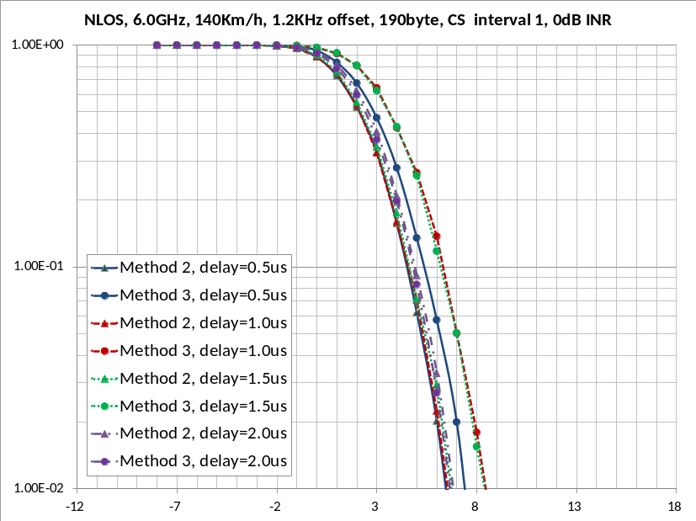
Fig. 12: Comparison the performance between methods 2 and 3 assuming CS interval 1, 0dB INR
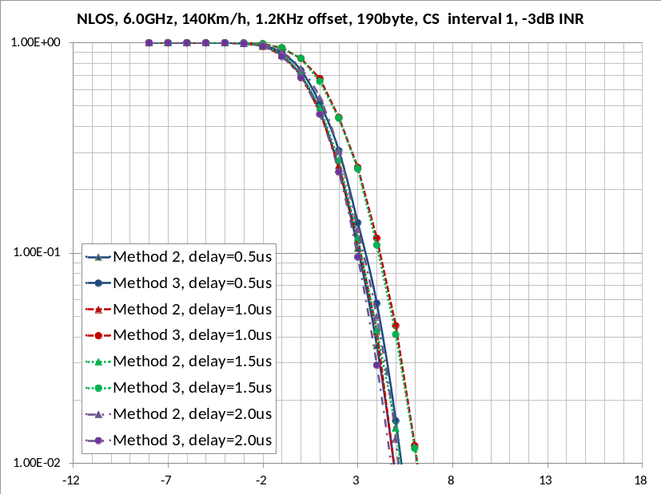
Fig. 13: Comparison the performance between methods 2 and 3 assuming CS interval 1, -3dB INR
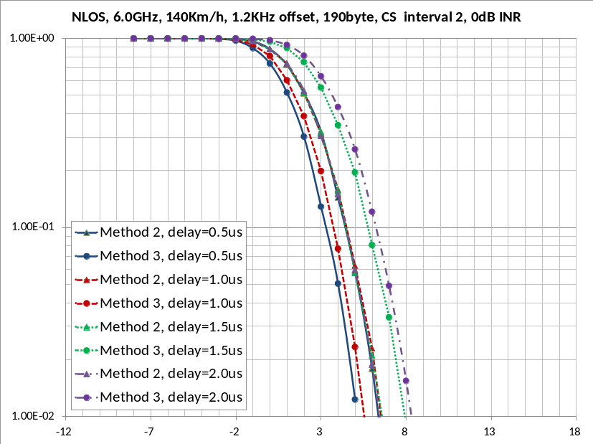
Fig. 14: Comparison the performance between methods 2 and 3 assuming CS interval 2, 0dB INR
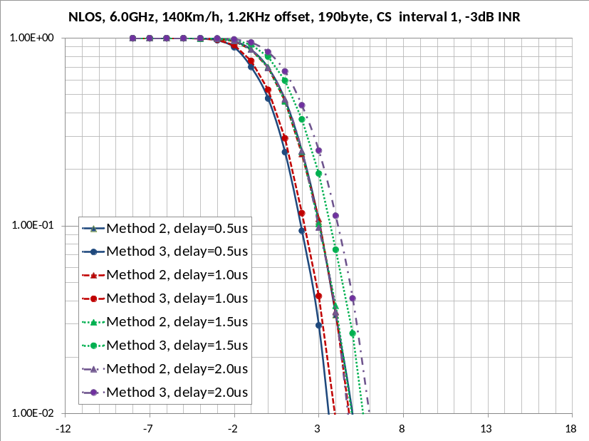
Fig. 15: Comparison the performance between methods 2 and 3 assuming CS interval 2, -3dB INR
We can see in figures 12 ~ 15 that the performance of method 2 is not almost different depending on reception timing delay. However, the performance of method 3 is affected considerably by reception timing delay even with a relatively low interference such as -3 dB, as expected in the above explanation. Especially, for the delay {1.0us, 1.5us} with CS interval 1 and for the delay {1.5us, 2us} with CS interval 2, the performance of method 2 can be better than that of method 3 by the overlapping RS sequences. We note that this issue of method 3 is not reflected in the SLS results which will be discussed below because of the assumption of perfect time synchronization. Differently from method 3, the performance of method 2 is not affected by the timing difference between the desired signal and interference.
In order to investigate more, we evaluated average PRR in the SLS for both of methods 2 and 3. We simulated urban scenario with vehicle speed 60km/h in table 2, and freeway scenario with vehicle speed 70km/h, 140km/h in table 3. For method 3, MPR and IBE are applied as shown in [1]. The resource allocation principle of “location-based resource allocation + URS-CA” and the corresponding simulation assumptions in [5] are used.
Table 2: Average PRR in the urban case
 | Urban case, 60km/h
Range (m) | Method 2 | Method 3
0 ~ 20 | 0.9337 | 0.9310
20 ~ 40 | 0.9240 | 0.9216
40 ~ 60 | 0.9055 | 0.9033
60 ~ 80 | 0.8738 | 0.8674
80 ~ 100 | 0.8307 | 0.8262
100 ~ 120 | 0.7725 | 0.7623
120 ~ 140 | 0.6866 | 0.6749
140 ~ 160 | 0.5995 | 0.5806

Table 3: Average PRR in the freeway case
 | Freeway case, 70km/h |  | Freeway case, 140km/h
Range (m) | Method 2 | Method 3 | Method 2 | Method 3
0 ~ 20 | 0.9293 | 0.9307 | 0.9318 | 0.9376
20 ~ 40 | 0.9205 | 0.9215 | 0.9375 | 0.9369
40 ~ 60 | 0.8928 | 0.8959 | 0.9194 | 0.9197
60 ~ 80 | 0.8710 | 0.8662 | 0.9087 | 0.9095
80 ~ 100 | 0.8343 | 0.8312 | 0.8980 | 0.8960
100 ~ 120 | 0.8037 | 0.7956 | 0.8831 | 0.8799
120 ~ 140 | 0.7899 | 0.7819 | 0.8798 | 0.8730
140 ~ 160 | 0.7824 | 0.7753 | 0.8665 | 0.8780
160 ~ 180 | 0.7698 | 0.7649 | 0.8689 | 0.8634
180 ~ 200 | 0.7690 | 0.7707 | 0.8717 | 0.8681
200 ~ 220 | 0.7674 | 0.7683 | 0.8695 | 0.8744
220 ~ 240 | 0.7664 | 0.7639 | 0.8883 | 0.8815
240 ~ 260 | 0.7789 | 0.7899 | 0.8875 | 0.8929
260 ~ 280 | 0.7818 | 0.7895 | 0.8978 | 0.8941
280 ~ 300 | 0.7890 | 0.7915 | 0.8954 | 0.9102
300 ~ 320 | 0.7810 | 0.7868 | 0.9019 | 0.9072
We can see in Table 3 that for the freeway case, the average PRRs of methods 2 and 3 are very similar. Also, it can be observed in Table 2 that for the urban case, the average PRRs of method 2 are slightly better than those of method 3.
Based on the above evaluated performance, described larger PAPR, smaller MCL, and more vulnerable delay spread issues of an OFDM-like approach, method 3 is not a preferable option especially considering the fact that a larger specification and implementation impact is expected. Therefore, solutions based on SC-FDMA such as method 2 should be the first priority in defining a solution to handle high Doppler case.
Proposal 1: Physical channel for PC5-based V2V should be based on the existing SC-FDMA waveform including the principle of TDM of RS and data.
Proposal 2: For DMRS enhancement, 4 symbols are used for DM RS in a subframe in normal CP and comp-type RS sequence is used to handle high Doppler effects and high frequency offset.
- Control channel
We evaluated control channel of methods 2 and 3 described in section 2. We simulated them in NLOS environment. In the simulation, 6.0 GHz carrier frequency, 280 km/h relative speed, {1.2, 2.4} KHz frequency offsets are assumed. For the transmission, 1RB single transmission is assumed. Also, we assumed the puncturing of the first and last symbols in the simulation. We plot simulation results of 30bit, 40bit, 60bit information size in figures 16, 17, 18, respectively.
The trend of simulation results for the control channel is very similar to those of data channel.
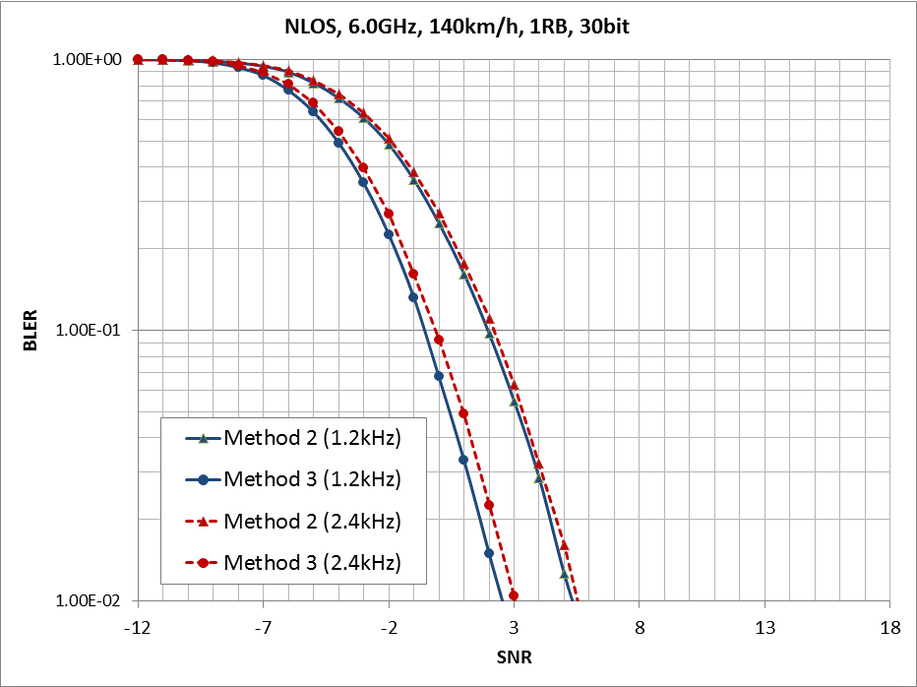
Fig. 16: Comparison the performance between methods 2 and 3 for 1RB and 30bit information size.
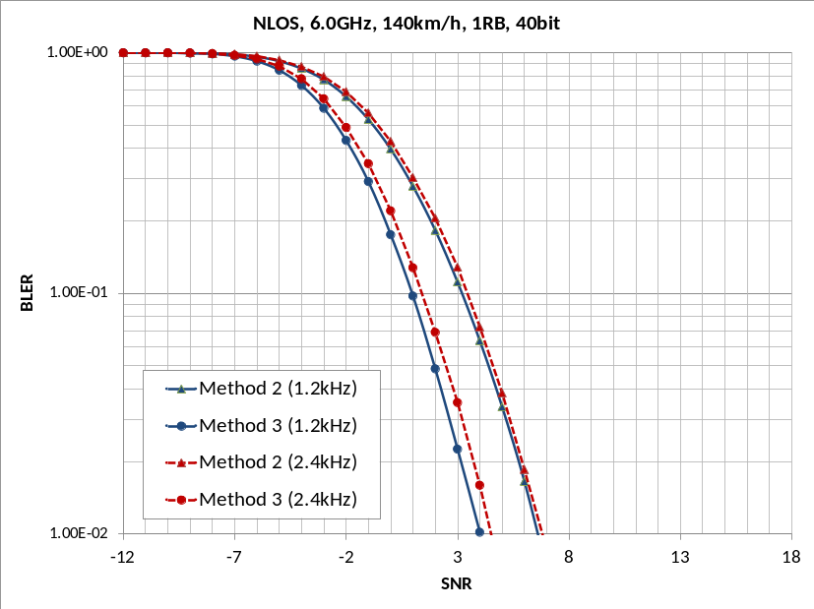
Fig. 17: Comparison the performance between methods 2 and 3 for 1RB and 40bit information size.
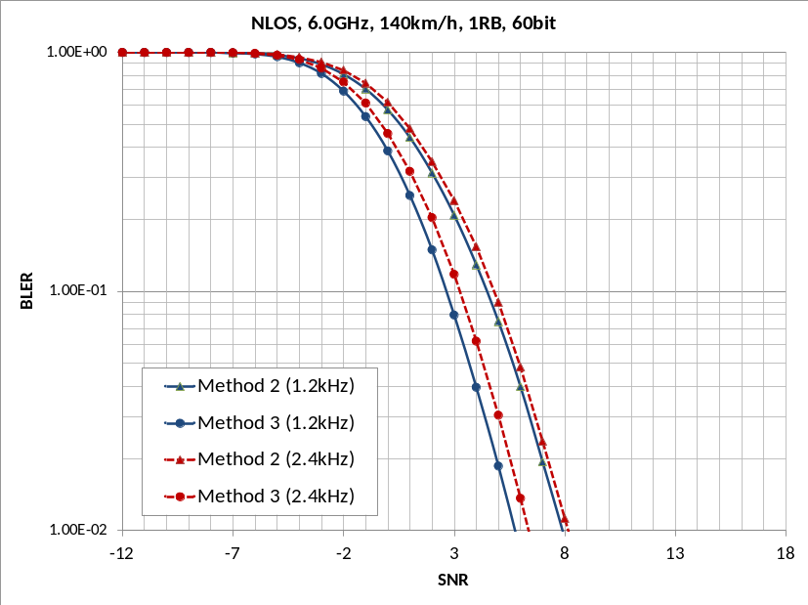
Fig. 18: Comparison the performance between methods 2 and 3 for 1RB and 60bit information size.
- Conclusion
This contribution discussed RS enhancements to handle high Doppler case. The proposals based on the discussion are given as follow:
Proposal 1: Enhancements to sidelink physical channel structure based on SC-FDMA waveform should be the first priority in further study.
Proposal 2: Comp-type RS sequence is appropriate to handle high Doppler effects and high frequency offset.
______________________________________________________________________
Reference
[1] R1-156897, “Discussion on MPR and inband emission model for different physical layer formats,” LG Electronics.
[2] R1-155907, “Physical Layer Format for V2X over PC5”, Ericsson.
[3] R1-094743, “Multiplexing Capacity of Uplink SRS in LTE-A”, ZTE.
[4] 3GPP TS 36.133 V13.1.0: Requirements for support of radio resource management.
[5] R1-156891, “Discussion on enhancement for PC5 based V2V resource allocation”, LG Electronics.
[6] R1-155418, “Discussion on solutions to handle high Doppler case”, LG Electronics.

Appendix A. Channel estimation method
This appendix introduces the process of compensation of phase offset for each method described in section 2 and 3.

Method 1
- RX UE estimates the frequency channel response in the four RS symbols.
- RX UE calculates the frequency-averaged phase rotation rate of each slot by comparing the frequency channel response of the two RS symbols in the same slot.
- RX UE compensates the received frequency signal of data symbols and the estimated frequency channel response of DMRS symbols of each slot by phase rotation rate obtained in 2).
- RX UE estimates the frequency channel response of data symbols in each slot by using interpolation of estimated channel of compensated received frequency channel of DMRS symbols in the slot.

Method 1’
- RX UE estimates the frequency channel response in the four RS symbols.
- RX UE calculates the frequency-averaged phase rotation rate of each subframe by all the three pairs of comparison of the frequency channel response of the two RS symbols in the same subframe.
- RX UE compensates the received frequency signal of data symbols and the estimated frequency channel response of DMRS symbols of each subframe by phase rotation rate obtained in 2).
- RX UE estimates the frequency channel response of data symbols in each subframe by using interpolation of estimated channel of compensated received frequency channel of DMRS symbols in the subframe.
Note that frequency slot hopping cannot be applied for method 1’.

Method 2
- In each RS symbol, RX UE separates the received time signal into two parts, where each part comes from one of repeated transmitted signal.
- RX UE transforms each part of received time signal into received frequency signal by applying half size of FFT, and estimates two frequency signals.
- RX UE calculates the frequency-averaged phase rotation rate within each DMRS symbol by comparing the two estimated frequency signals in the DMRS symbol.
- RX UE compensates the received frequency signal of each DMRS symbol and neighboring two data symbols on both hands of the DMRS by phase rotation rate obtained in 2).
- RX UE estimates the frequency channel response of data symbols in each slot by using interpolation of estimated channel of compensated received frequency channel of DMRS symbols in the slot.
We note that the channel estimation used in simulations for Method 2 is a bit modified for performance improvement compared to that in [6]. In particular, the slow-wise interpolation in Step 5 provides some gain in the channel estimation.

Method 3
- RX UE estimates the frequency channel response in all the RS symbols in the subframe by using DMRS over two REs per RB.
- There is no need to estimate phase rotation by frequency offset.

Appendix B. LLS simulation assumptions
Table 2: LLS simulation assumptions
Parameters | Assumptions
System bandwidth | 10 MHz
Carrier frequency | 6 GHz
Channel model | ITU-R UMi NLOS CDL model with dual mobility
Antenna configuration | Tx 1 antenna  Rx 2 antennas
UE relative speed | {30, 280} km/h
Modulation | QPSK
TBS of PSSCH | {190, 300, 800} bytes for data channel  {30, 40, 60} bits for control channel
PRB | 10 for {190, 300} bytes  20 for 800 bytes  1 for {30, 40, 60} bits
CFO | {1.2, 2.4}KHz
AGC | Yes
GP | Yes
Number of transmissions | 2 times for 190 bytes  3 times for 300 bytes  4 times for 800 bytes  1 time for {25, 40, 60} bits
Channel estimation | See Appendix A

This showed the best performance among several possibilities of placing 4 DM RS symbols in a subframe.

